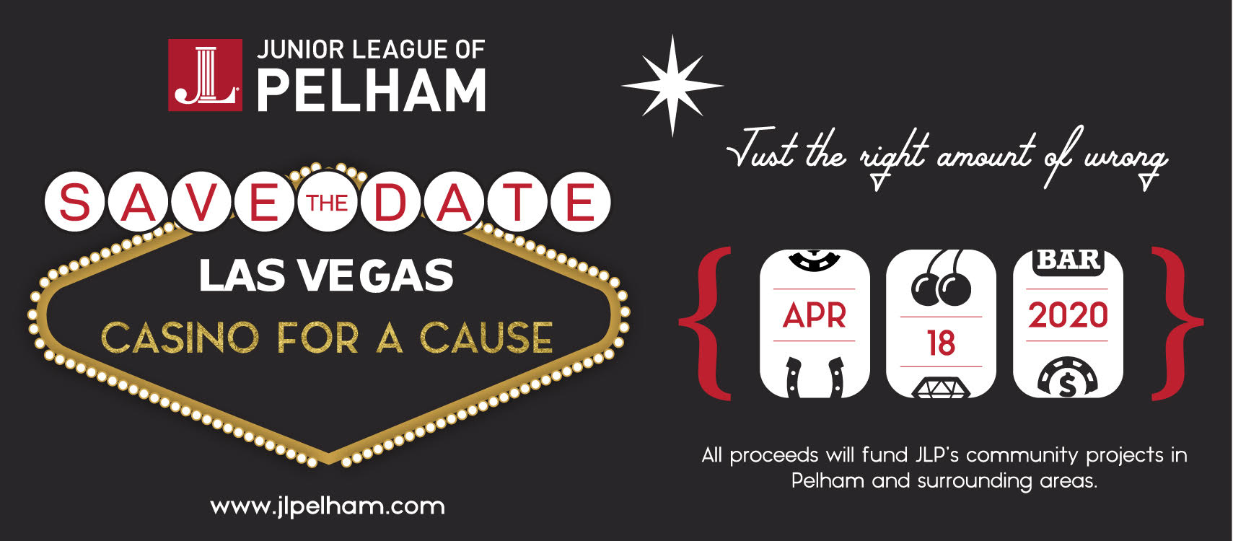
Auction/Raffle Donation Form 2020
Company:
Individual’s Name:____________________________________________________________________
Address: ___________________________________________________________________________
City: _________________________________ State:_________________ Zipcode:_______________
Phone: _________________________E-mail:
Web site: _________________________
I/we hereby authorize the following donation to The Junior League of Pelham:

VALUE OF ITEM: $ ___________ DESCRIPTION OF ITEM:
__________________________________________________________________________________
______________________________________________________________________
CONTACT PERSON:_____________________________________________________________
EXPIRATION DATE:________________________________________________ ______
EXCLUSIONS:______________________________________ _________________
REDEMPTION INSTRUCTIONS:_______________________________________________________
RESTRICTIONS/BLACKOUT DATES:_________________

PICK UP, DROP OFF OPTIONS: (Check one, if applicable)
 I, or a representative of my company, will bring the above listed item(s) to the Junior League office or specific site as pre-arranged by JLP contact person. I will receive a written confirmation
 Requesting a JLP contact person pick up the item.
Thank you for your support,
Penny O’Brien and Meredith McGinn, VP Fund Development, Annie Fagbeyiro and Sylvia Wong, Cmte Chairs
New York tax exempt identification is # 134615. For purpose of tax deduction, we have been informed by the IRS that a contributor may estimate a fair and market value of this contribution. No goods or services were received in exchange for this donation.

Please email completed form to Annie Fagbeyiro cafagbeyiro@gmail.com

